Playing with colours

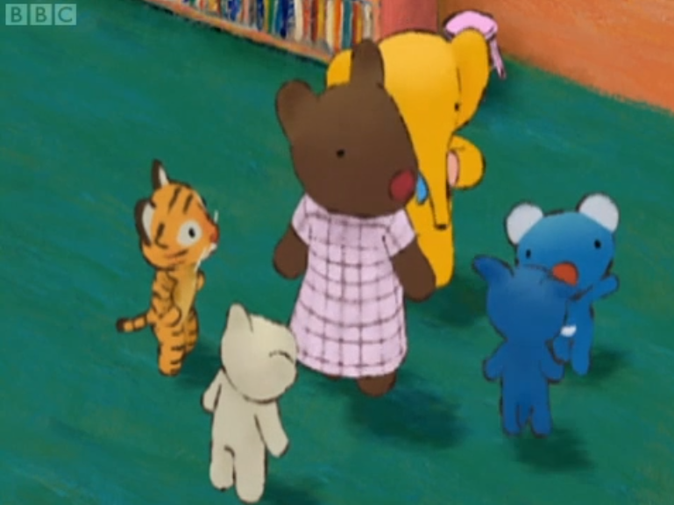

Penelope and her friends are going to play with colours today. What is playing with colours?

Colour ,colour, colour, colour, what colour?

What colour do you like ,tell us please?

Yellow.

Yellow, where is it?

Let’s look around.

Yeah!

Do you think you can find something yellow?

This isn’t yellow. And this isn’t yellow either.

I found something. This is yellow. Yellow!

I found something too. Yellow!

Wow, ouch! Yellow, wait!

Oh, yellow. I found something.

I see. This is how they play with colours. So ,everyone found something yellow. It looks fun.

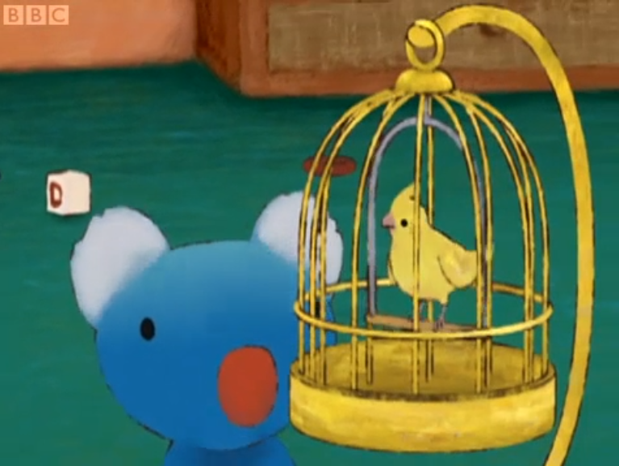

Colour ,colour, colour, colour, what colour?

What colour do you like ,tell us please?

Blue!

Blue! I found blue!

En ,blue，blue....

Oh, yeah, blue!

This isn,t blue. This isn’t either.

Lily rose, there is something blue. Look!

Wow! Yes, blue!

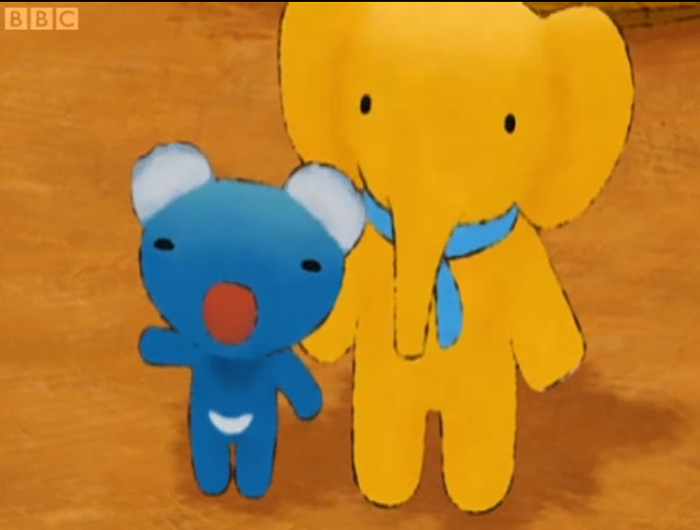

Colour ,colour, colour, colour, what colour?

What colour do you like ,tell us please?

Green!

Green! Green! Yeah!

I found something too.

Hey, wait, wait... But butterflies are not green. And dragonflies aren’t green either. En? Green!

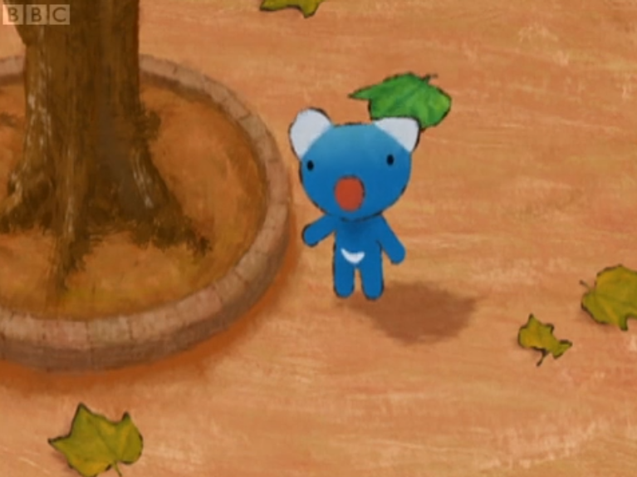

Colour ,colour, colour, colour, what colour?

What colour do you like ,tell us please?

Red!

Red! En ... Red! En ...

This isn’t red.

And this isn’t red either.

But this book is red.

Wow! You found something, daddy. I want to find something too.

Oh, you will. It’s right here,somewhere.

Right here? But where could it be?

Can you find something red? I wonder where it is.

Look! Look at your face in the mirror.

Oh,yes. I’ve forgot. Yes, I found it. My nose is red!

Did you find it too? Playing with colours was fun.

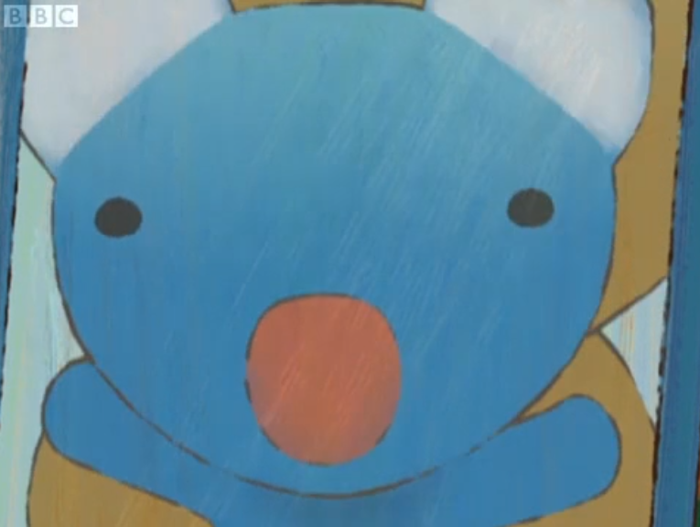

**Chinese dragon**

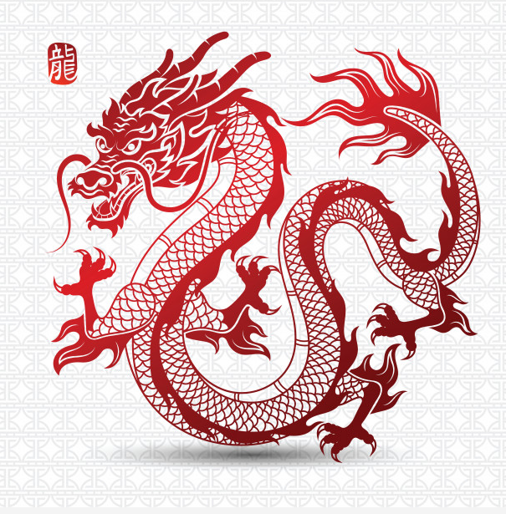

**Western dragon**

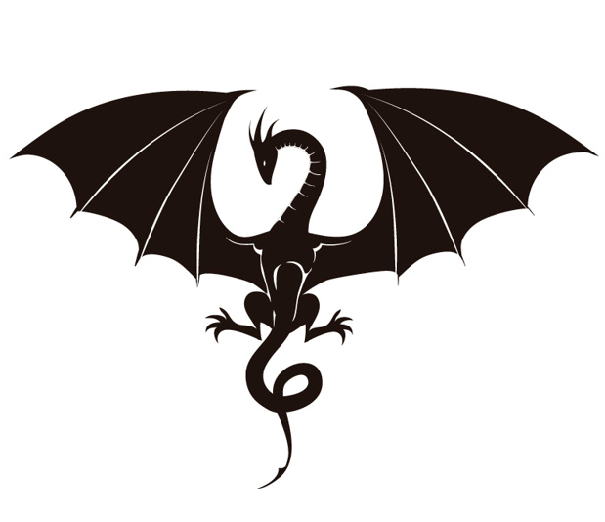

**fly / flies**

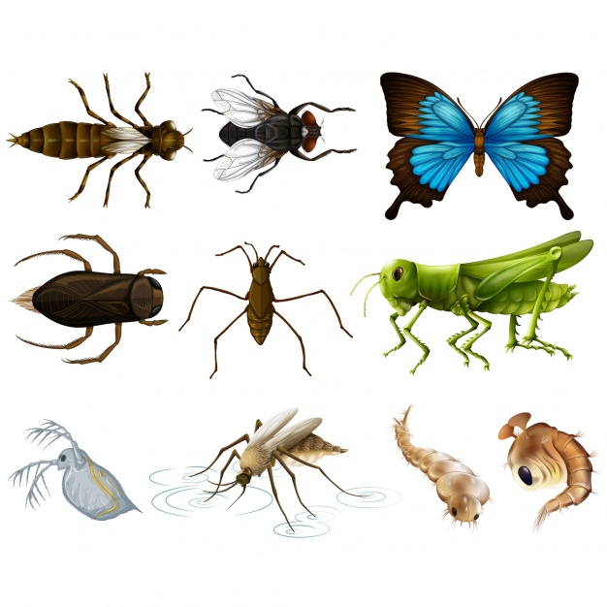

**dragonfly**

